**Manual for Data Visualization and Analytics**

**R and Rstudio**

To run the R project, you must download and install R and Rstudio into your PC. The link below provides a step by step example on how to install R and Rstudio.

<https://courses.edx.org/courses/UTAustinX/UT.7.01x/3T2014/56c5437b88fa43cf828bff5371c6a924/>

**How to run the R file**

The following steps should be followed to run the R file.

1. Open the Melbourne Housing Map Visualization folder.
2. Look for the files with file type R File and open the file.

Note: the Rstudio IDE should open and show the code for the selected R File.

1. Press the run button or user the shortcut ctrl+alt+r.

**How to use the visualisation**

The Visualization Software has a data filter feature where the user can input a filter on the fields in Figure 1. When an input is added, the map markers will automatically adjust.

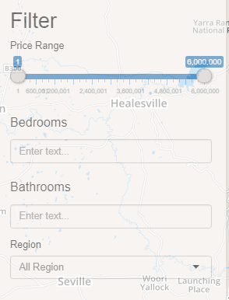

*Figure 1.* Data Filters

Another feature is the data exploration tab, where the user can see the raw data in a table and can search for a specific word. Because it is important for the user to see more information about the data.

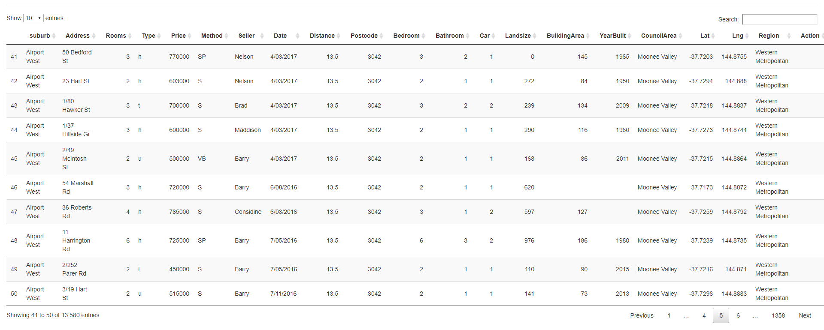

*Figure 2.* Raw Data Visualization